Lunar Mining Onboard Loopback Packet Structure

# Justification

The AI subsystem and the communications and control subsystems are being developed in parallel by two different groups of team members in two different languages. Further, the two languages are at two vastly different levels of abstraction. The AI subsystem is being developed in MATLAB, an interpreted, loosely typed, high-level scripting language. The communications and controls subsystems are being developed in C, a low-level, compiled, strongly-typed, imperative language.

These differences demand a simple common way to communicate between the MATLAB-based AI and the rest of the system. UDP Loopback ports are familiar to the developers of all subsystems, and provide a simple interface with sufficient performance.

# UDP Loopback Port Allocation

The AI subsystem and the communications subsystem will each only listen on a single UDP Loopback port. All other message routing must be handled internally.

The AI subsystem will listen on port 10001.

The communications subsystem will listen on port 10000.

# UDP Startup Handshake

To determine if both subsystems have finished booting, both the communications and the AI subsystems will participate in a startup handshake before the AI subsystem starts performing any calculations.

## AI Subsystem Startup

The AI subsystem should perform the following actions on startup

1. Broadcast ALIVE packet to either all UDP Loopback ports or specifically to port 10000
2. On receiving an ACK packet, start performing normal operations

The following is an example state machine implementing the AI subsystem startup protocol

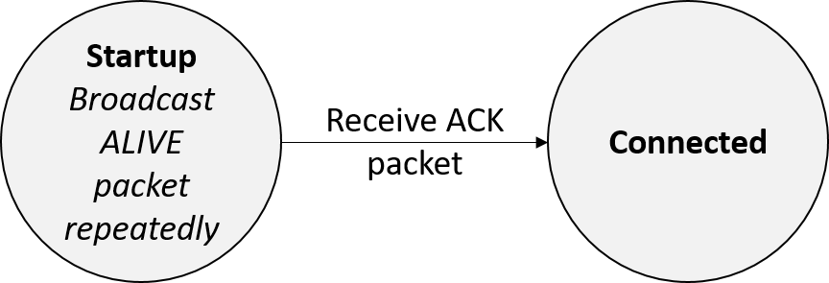

## Communications Subsystem Startup

The communications subsystem should perform the following actions on startup

1. Listen for ALIVE packet on all UDP Loopback ports, or specifically on port 10000
2. On receiving an ALIVE packet, send a single ACK packet to the origin of the ALIVE packet
3. Start performing normal operations

The following is an example state machine implementing the communications subsystem startup protocol

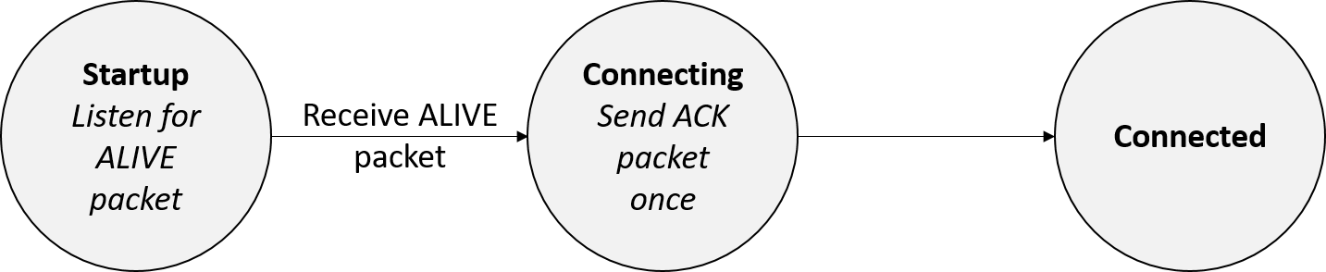

# UDP Packets

Each UDP Loopback packet consists of a start byte, an opcode byte, a payload-size byte, 0-255 payload bytes, and an end byte.

|  |  |  |  |  |
| --- | --- | --- | --- | --- |
| Byte 0 | Byte 1 | Byte 2 | Byte 3 to Byte *n*-1 | Byte *n* |
| Start Byte | Opcode | Payload Size | Payload | End Byte |
| 0xBE | See Opcodes table | Unsigned 8-bit integer | 0-255 bytes  See Opcodes table for specific formats | 0xAD |

## Specific Packets

The Opcode field in each packet identifies the purpose of each packet, as well as the acceptable values for the Payload Size and Payload fields of a packet.

|  |  |  |  |  |  |  |
| --- | --- | --- | --- | --- | --- | --- |
| Opcode | Name | Purpose | Payload Size | Payload Format | | |
| Byte Number | Format | Data |
| 0x00 | ACK | General purpose acknowledgement | 0 | N/A | N/A | N/A |
| 0x01 | ALIVE | General purpose heartbeat | 0 | N/A | N/A | N/A |
| 0x02 | INIT | Start mining run | 0 | N/A | N/A | N/A |
| 0x03 | LOC | Report current location | 6 | 0 | Two’s Complement, centimeters from center of collection bin. When facing directly away from collection bin, left is positive and right is negative. | Current location x-coordinate, most significant byte |
| 1 | Current location x-coordinate, least significant byte |
| 2 | Unsigned, centimeters from collection bin | Current location y-coordinate, most significant byte |
| 3 | Current location y-coordinate, least significant byte |
| 4 | Two’s Complement, degrees from facing directly away from collection bin. Clockwise is positive, counterclockwise is negative. Capped between -180 and +180. | Current heading, most significant byte |
| 5 | Current heading, least significant byte |
| 0x04 | TARGET | Designate target location | 6 | 0 | Two’s Complement, centimeters from center of collection bin. When facing directly away from collection bin, left is positive and right is negative. | Current location x-coordinate, most significant byte |
| 1 |  | Current location x-coordinate, least significant byte |
| 2 | Unsigned, centimeters from collection bin | Current location y-coordinate, most significant byte |
| 3 |  | Current location y-coordinate, least significant byte |
| 4 | Two’s Complement, degrees from facing directly away from collection bin. Clockwise is positive, counterclockwise is negative. Capped between -180 and +180. | Current heading, most significant byte |
| 5 |  | Current heading, least significant byte |
| 0x05 | ENCODER | Report encoder data | 12 | 0 | Two’s complement, encoder ticks since last reading | Left-front wheel, most significant byte |
| 1 | Left-front wheel, least significant byte |
| 2 | Two’s complement, encoder ticks since last reading | Right-front wheel, most significant byte |
| 3 | Right-front wheel, least significant byte |
| 4 | Two’s complement, encoder ticks since last reading | Left-back wheel, most significant byte |
| 5 | Left-back wheel, least significant byte |
| 6 | Two’s complement, encoder ticks since last reading | Right-back wheel, most significant byte |
| 7 | Right-back wheel, least significant byte |
| 8 | Two’s complement, encoder ticks since last reading | Left linear actuator, most significant byte |
| 9 | Left linear actuator, least significant byte |
| 10 | Two’s complement, encoder ticks since last reading | Right linear actuator, most significant byte |
| 11 | Right linear actuator, least significant byte |